Preparation of papers for IJET
First A. Author, Second B. Author, and Third C. Author
Abstract—This instruction gives you guidelines for preparing papers for International Journal of Electronics and Telecommunications. Use this document as a template in Microsoft Word. The whole manuscript (including the abstract) should be written in English. The length of the manuscript should be kept within reasonable number of pages. The abstract should give short summary of the paper, stating clearly the new and original contribution of the paper or its relation to the state-of-the-art of the field. An abstract should not normally exceed 100 words.

Keywords— technology, electronics, optoelectronics, photonics, telecommunications, signals. circuits, systems, applications

Introduction
T
HE submitted manuscript should be prepared strictly according to the guidelines presented in this paper. We accept papers prepared in MS Word (97 or higher) or OpenOffice text editors. The text of the manuscript should be typed within the area of 227 mm x 170 mm: on the standard A4 paper it is equivalent to the 35 mm margins at top and bottom, and 20 mm margins at left and right. The paper should be typed single-spaced using Times New Roman font. Text should be 10-pt., the title should be 16-pt., and the abstract, figure captions and references should be 8-pt.
The title of the paper is to be typed in lower case. Please use superscript characters to reference names to proper authors’ affiliations, which are to be typed in italic fonts after authors’ names. Give also e-mail address of the corresponding author (not necessarily the first author) marked by an asterisk.
Equations should be placed within the text. They should be centred and numbered successively with arabic numerals (minor non-referenced expressions might be not numbered). The equation’s number should be positioned in parentheses right justified at the line of the equation:
Table Name
Column 1 | Column 2 | Column 3 ª
xx1 | yyy1 | zzz1
xxx2 | yy2 | zzz2
xxx3 | yyy3 | zz3
xxx4 | yy4 | zzzzz4
xxx5 | yyyyy5 | zz5
ª[Footnote Text] Content.

TABLE I
[Table Title] Table Name
Column 1 | Column 2 | Column 3 ª
xx1 | yyy1 | zzz1
xxx2 | yy2 | zzz2
xxx3 | yyy3 | zz3
xxx4 | yy4 | zzzzz4
xxx5 | yyyyy5 | zz5
ª[Footnote Text] Content.

(1)
Variables should be set in italics while functions, standard quantities, constants, and numerals should be set in romans. Vectors and matrices should be indicated by bold romans or bold italics, e.g. a or a for vectors and A or A for matrices.
All figures and tables should be numbered and always referred to in the text. Figures should be clear and be finished high-quality artworks. Lettering should be large enough to be readily legible. Image quality is very important to how yours graphics will reproduce. If your graphic looks low in quality on your printer or monitor, please keep in mind that cannot improve the quality after submission.
Refer to equations by their numbers in parentheses or write out the word equation (do not abbreviate) and the number. Figures should be referred to in the abbreviated form Fig. (but use Figure when starting a sentence) while referring to table requires the form Table, e.g. Table 1.

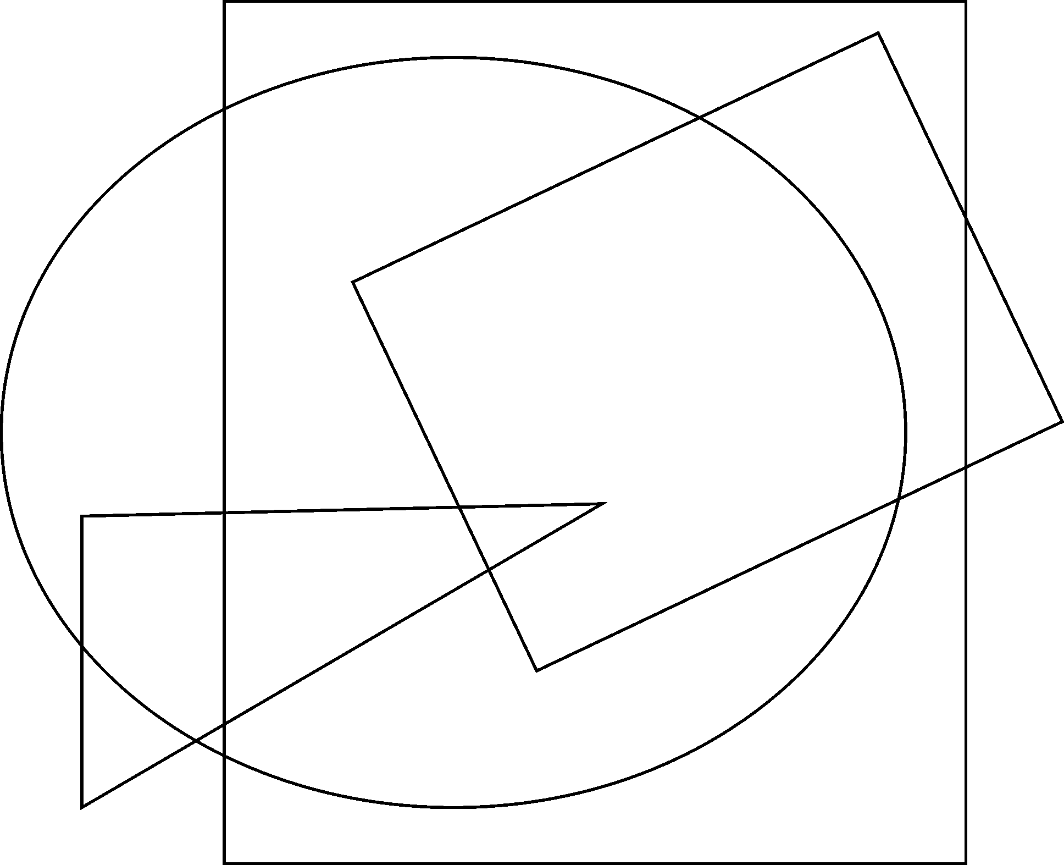
Fig. 1. Example of figure. Explain the significance of the figure in the caption.
References in the text should be numbered sequentially in the order in which they appear. Place their numbers in square brackets, for example [1]. Some sample references in a bibliography will follow in the last section of this paper [1]-[4]. Give all authors’ names; do not use “et al.” unless there are six authors or more. Use a space after authors’ initials. Internet links may be included as references. Internet links should list the author and the full URL (universal resource locator). Use DOI in references.

[Heading 1]

[Heading 2]

References
- A. B. Author, “Book style with paper title and editor,” in Title, 1nd ed. vol. 1, C. Editor, Ed. City: Publisher, 1999, pp. 10–50.
- F. Author, G. Author, H. Author, and I. Author, “Journal style,” Journal, vol. 1, Jan. 1999, pp. 140–151 [Conference, 1998, pp. 300-307].
- F. Author and Z. Author, “Journal style,” Journal, vol. 2, pp. 1–21, Jan. 2001.
- J. A. Author, “Periodical style,” Periodical, vol. 1, no. 1, pp. 30–38, Jan. 1999.
- K. A. Author, “Published Conference Proceedings style,” in Proc. Conference, City, 1999, pp. 18–26.
- L. A. Author and M. Author, “Presented Conference Paper style,” presented at Meeting (Conference), City, Jan. 2–7, 1999, Paper identifier (optional).

This work was supported ... (sponsor and financial support acknowledgment goes here). First Author is with ... (affiliation goes here) (e-mail: ... ). Second Author is with ...

